https://doi.org/10.26442/26586630.2019.1.190314

**Review**

Ectoine – a microbial metabolite with unique biotherapeutic properties

## Vladimir I. Kocherovets🖂

I.M.Sechenov First Moscow State Medical University of the Ministry of Health of the Russian Federation. 8, 2 Trubetskaia str., Moscow, 119991, Russian Federation

🖂[kftif@mail.ru](mailto:kftif@mail.ru)

**abstract**

Objectively assess the practical importance of the clinical, pharmacological and pharmaceutical characteristics of products and preparations based on ectoine is impossible without a deep analysis of all the circumstances in which the therapeutic effect of this microbial metabolite occurs. Therefore, on the one hand, it is necessary to pay due attention to the skin and mucous membranes as special biological targets for ectoin molecules. On the other hand, one cannot underestimate the uniqueness of ectoin-containing protective agents aimed at preventing and arresting the manifestations of pathological processes and symptoms in various conditions and diseases of the respiratory system, gastrointestinal tract and skin. At the same time, the use of various commercial products in medicine and cosmetology still occurs under conditions when the mechanism of action of ectoine is not fully understood. Under these circumstances, the necessary clarity can brought out by the results of new clinical and experimental studies of metabolites of the group of ectoine. These data should strengthen the position of ectoine and its derivatives as effective and safe therapeutic agents for medical and cosmetic use.

**Key words:** therapeutic agents for local use, microbial metabolites, ectoine, release forms.

**For citation:** Kocherovets V.I. Ectoine – a microbial metabolite with unique biotherapeutic properties. Pediatrics. Consilium Medicum. 2019; 1: 108–115. DOI: 10.26442/26586630.2019.1.190314

# Introduction

The evolution of microorganisms on Earth took place in severe conditions of an extreme environment [1]. One of the mechanisms of adaptation of living organisms to severe environmental conditions, for example, to dehydration and excessive salinity, was the synthesis of low molecular weight compounds known as “compatible solutions” or “compatible solvents” (osmolytes, osmoprotectors) [2]. These substances allowed organisms to remain viable under extreme natural conditions [3]. Originally, osmoprotectors are secondary metabolites that prevent harmful dehydration of cells without undesirable modulation of basic cellular metabolism. The source material for osmolytes is the primary metabolites, which have undergone coordinated configuration.

Most secondary metabolites are complex organic molecules whose intracellular synthesis requires a large number of specific enzymatic processes [4]. Simple metabolites of this group, as well as complex metabolites, may have pronounced biological activity, including osmoprotective activity. A product of microbial synthesis ectoine belongs to simple secondary metabolites with pronounced activity [5].

Many halophilous* and halotolerant** microorganisms accumulate low molecular weight intracellular solutions to ensure osmotic balance with the extracellular hypersaline environment [6]. Some of the osmolytes are synthesized using biotechnological production and have commercial applications [7, 8].

*Microorganisms which require high concentrations of salt for their existence.

**Microorganisms which are resistant to the presence of high salt concentrations, but prefer salt-free conditions for growth [3].

These include, for example, glycine, betaine, sucrose, trehalose, various polyols, various amino acids and their derivatives [9, 10].

**Ectoine** or 1,4,5,6-tetrahydro-2-methyl-4-pyrimidin-carboxylic acid is an osmolyte in halophilic and halotolerant procaryotes, one of the most common osmotic products of bacterial origin, a polyfunctional bioprotector [5, 11]. Currently, it is known that the primary activity of ectoine is its ability to stabilize protein molecules and cell membranes on the basis of a kosmotropic effect, which provides for the enhancement of the physical water structure.

The product name “ectoine” is consonant with the former name of haloalkyphilic sulfur purple bacteria of the species *Ectothiorhodospira halochloris*, from which this metabolite was first derived [5, 11]. Currently, the specified microorganisms belong to the bacterial species *Halorhodospira haloрhila* [14]. The updated history of the discovery of a unique metabolite officially relates to the extreme halophile *Halorhodospira haloсhloris*, of a phototroph growing in the presence of 5M NaCl [5]. Later it was found that many halophilic and halotolerant bacteria, including representatives of *Actinobacteria*, *Firmicutes* and *Proteobacteria*, synthesized ectoine in combination with a 5-hydroxy derivative [15, 16].

The specified microorganisms produce and accumulate intracellular ectoines to ensure osmotic balance with excessive salinity of the environment [17, 18]. Therefore, organisms eliminate salt from the cytoplasm, canceling the need to adapt their intracellular proteins to the presence of high salt concentrations. In recent years, a significant number of such “compatible solutions” of microbial origin have been identified and characterized [19]. Ectoines can protect many unstable enzymes, as well as nucleic acids from harmful effects of high salinity, thermal denaturation, drying-out and freezing, thereby increasing the shelf life and activity of enzyme preparations [19-22]. For example, ectoine is able to modify various processes associated with the conversion, catalysis, and stabilization of the activity of trypsin and chymotrypsin [23]. Such compatible dissolved substances are sometimes referred to as "molecular chaperones".

**Biosynthesis of ectoine**  from aspartate, a cyclic amino acid, is carried out with the participation of specific enzymes: 2,4-diaminobutyrate (DUB) -aminotransferase (EctB), DUB-acetyltransferase (EctA) and ectoine synthase (EctC) [12]. The route of ectoine biosynthesis is a branch in the route of amino acid synthesis of the aspartate family. In recent years, attempts have been made to study in detail the properties of enzymes and genes of this biochemical route, which is stipulated by the practical tasks of obtaining a promising bioprotector of ectoine used in medicine and cosmetics, as well as in scientific practice as a water-retaining agent and stabilizer of biomolecules and whole cells [13]. In addition to ectoine, halophiles also produce its derivative 5-hydroxyectoine, that is also a bioactive compound. The biosynthesis of hydroxyectoine is carried out by direct hydroxylation of ectoine by ectoine hydroxylase (EctD) [13].

# History of ectoine manufacturing

The principle and method of ectoine manufacturing with the aid of a producing strain Halomonas elongata ATCC 33173 was patented in 1994 by the German biotechnology company Bitop AG (Germany) [7]. Other strategies for the manufacturing ectoines are also available in the literature [24-26]. The most well-known technology for manufacturing ectoine involves the extraction of compounds from halophilic bacteria.

Industrial processes for the mass manufacture of ectoine and hydroxyectoine were developed with the aid of producing strains *Halomonas elongata ATCC 33173* and *Marinococcus M52*, respectively. The procedure is based on the phenomenon of “bacterial milking” [27, 28]. In 1998 T. Sauer and E.Galinski [27] developed this manufacturing biotechnological process using *H. elongata* as an ectoine-producing source. At “bacterial milking”, a producing strain is grown to a high cellular concentration in a hypersaline environment. This leads to the accumulation of a large quantity of intracellular ectoines. Then an osmotic lowering shock is applied, i.e. a microbe from the conditions of the hypersaline environment moves to the environment with low salinity. Producers get rid of their own ectoine and other compatible solutions to maintain the required osmotic balance. The bacteria react by releasing most of the ectoine into the environment from which the compound can be collected by filtration and purified. Then salt is again added to the culture medium to a high salinity level, which stimulates the synthesis of a new portion of a metabolite. The specified process can be repeated several times, alternately manipulating the culture media with high and low salinity, thus providing industrial volumes of the product. Long-term research on the development, research, and manufacture of ectoine allowed Bitop AG to become the only industrial manufacturer of this product certified in accordance with the requirements of ISO 13485 [29].

# Scope of ectoine application

At present, there is an obvious demand for ectoine in the field of pharmaceutical applications and other applied areas of human activity [8, 9]. However, only an industrial form for obtaining a metabolite can ensure the successful entry of commercial products into the modern consumer market, especially in the form of pharmaceutical preparations and devices for medical and cosmetic use [7, 8, 16].

Medical use of ectoine determines the need to assess the degree of knowledge of this substance as a therapeutic agent. In recent years, an increase in the number of studies on the various therapeutic and prophylactic properties of ectoines for use in medicine and cosmetology has been observed [7–9].

A. Roychoudhry et al. [30] showed that ectoine, like other compatible solutions, enhances the intramolecular interaction required for protein stability. It reduces the denaturation of enzymes induced by temperature fluctuations and prolongs the activity of lactate dehydrogenase (LDH) and phosphofructokinase, enzymes that are usually sensitive to freeze-thawing, heating and cryogenic drying [31]. Ectoine also increases the stability of phytase, ribonuclease A, and polymerase of two-stranded DNA at increased temperatures [32, 33]. C.Tanne et al. [34] found that the ectoine derivative, 5-hydroxyectoine, was superior to ectoine in the degree of protection against increased temperatures.

The ability of ectoine to protect macromolecules from the action of proteolytic agents is of particular interest. For example, chymotrypsinogen and trypsinogen zymogens were resistant to proteolysis by enteropeptidases [23]. Ectoine can inhibit HIV replication [33], as well as stabilize retroviral vectors for gene therapy, which can be a useful feature since these vectors usually lose infectivity during prolonged storage and transportation [35].

# Treatment of allergic rhinitis and rhinoconjunctivitis

At present, the most popular area of therapeutic use of ectoine is the treatment of allergic processes in which the mucous membranes of eyes, nose and a respiratory tract are involved in a pathological process [36]. A series of clinical trials with elements of a meta-analysis conducted by Bitop AG from 2010 to 2014 significantly strengthened the manufacturer’s initial information base on the use of ectoine-containing agents for allergic rhinitis (AR) and rhinoconjunctivitis in children and adults [37, 38]. The results of international studies showed that ectoine had a significantly more pronounced effect on the dynamics of nasal and ocular symptoms compared with placebo. In the group of patients who received ectoine, the regression of nasal allergy symptoms (runny nose, nasal cavity itching, nasal congestion, sneezing) was 19.6%, which was significantly higher compared with the group of patients who used placebo. The positive dynamics of eye symptoms (itchy eyes, red eyes, runny eyes) was even more significant: in a group of patients who used ectoine the reduction of eye symptoms was 24.4%, while this parameter was only 15.8% in a placebo group. The specified differences showed high statistical significance (*p* = 0.023). The ectoine solution was non-inferior in efficacy and target medicinal products (beclomethasone, azelastine, and cromoglycic acid) in the form of a spray [39].

At present, ectoine-containing products intended for medical use during AR and rhinoconjunctivitis are available in many countries around the world. In particular, in Austria, Germany, Israel, Jordan, Italy, Kuwait, Lebanon, Liechtenstein, the United Arab Emirates, Poland, Saudi Arabia, Slovenia, Ukraine, Croatia, the Czech Republic, Switzerland, etc. [46]. In Russia, the only medicinal product with ectoine intended for clinical use during AR is the medical device nasal spray Aqua Maris® Ectoin (Jadran d.d., Croatia).

**Nasal spray Aqua Maris®** **Ectoin** is a natural product that contains a combination of ectoine and an isotonic solution of sea salt. Due to its high hydrophilic properties, ectoine, which is a part of the preparation, forms a kind of “water shield” (Ectoine Hydro Complex) on the surface of the nasal mucosa. Such a "water coat" prevents the adhesion of allergens and other foreign particles. Whereby, allergens become fixed on the surface of the Hydro Complex and can be effectively removed from the nasal cavity when washing it or blowing out. The sea salt which is a part of a preparation promotes regeneration of a mucous membrane, damaged under the influence of allergens. Ectoin Hydro Complex possesses a powerful membrane-stabilizing effect and thus reduces the severity of an inflammatory response. Therefore, a nasal spray Aqua Maris® Ectoin protects against an allergy and reduces the severity of AR manifestations [43-45].

At present, many domestic pediatricians, ENT specialists, immunologists and allergists, and general practitioners have the necessary experience in the use of a nasal spray Aqua Maris® Ectoin [40–42]. The widespread introduction into the clinical practice of a nasal spray Aqua Maris® Ectoin has opened an innovative direction for the efficient prevention and arrest of pathological manifestations of AR in children and adults. Studies of S.I. Bardenikova et al., 2016 can be considered as a practical confirmation of the clinical efficacy of a spray Aqua Maris® Ectoin in pediatric practice [43].

Proceeding to the study, the authors took into account the peculiarities of the unique formula of Aqua Maris® Ectoin, which includes a combination of ectoine and an isotonic solution of sea salt - Ectoine Hydro Complex, which prevents allergens from contacting mucosal cells.

In the course of the work, the researchers found that there was a decrease in the Total Nasal Symptom Score - TNSS. This confirms the efficacy of local barrier therapy at various schedules for the treatment and rehabilitation of AR, regardless of its use as a part of mono or complex therapy with topical pulmonary glucocorticosteroids. Barrier therapy with an ectoine containing nasal spray accelerates and maintains the therapeutic effect, especially in cases where contact with allergens is completely impossible to eliminate (house dust, epidermal allergens). The clinical results obtained by the authors allowed to determine the place of an ectoine nasal spray in the algorithm of treatment of children suffering from all-year AR [43].

No less convincing are the materials of clinical trials conducted by A.V. Kamaev and O.V. Trusovа, 2015 [44], who, according to the results of this work, recommend to include Aqua Maris® Ectoin, based on ectoine, into therapeutic schemes of “barrier” preparations. This will let to reduce the frequency of acute conditions of AR, to reduce the severity of daily symptoms and significantly improve the well-being of patients. In their article, the authors described in detail ectoine (1,4,5,6-tetrahydro-2-methyl-4-pyrimidinecarboxylic acid) as a compound biologically produced by bacteria that have to live in extreme living conditions, including high temperatures, the influence of increased salinity, ultraviolet radiation. Ectoine of microbial cells contributes to the formation of a protective and stabilizing "water capsule" on a protein surface, protecting molecules from structural changes and water loss. In addition, stability and flow properties of cell membranes increase. Such stabilization of the epithelial membranes of nasal and ocular mucous membranes in humans prevents potential water loss and protects allergenic molecules from penetrating the mucous membrane. Today, ectoine is widely used in skin care products to treat atopic dermatitis; moreover, nasal sprays and eye drops with ectoine are being actively introduced into the world clinical practice. Toxicological studies and tolerability studies have shown an extremely favorable safety profile of products consisting of ectoine. In conclusion, A.V.Kamaev and O.V.Trusova have noted that according to the results of an open, prospective, controlled, non-comparative study of Aqua Maris® Ectoin during the treatment of persistent AR of varying severity in children and adolescents, its clinical efficacy and good tolerance have been confirmed. The obtained results allow us to recommend the use of the preparation Aqua Maris® Ectoin to treat persistent AR in children, both as a part of a scheduled treatment and as an immediate preventive medicinal product just before contact with a causative allergen. These recommendations comply with an established clinical practice and the provisions of international guidelines on the management of AR in children and adolescents [44].

Studies conducted by M.A. Mokronosova et al. [45] in Moscow region, which investigated the efficiency of monotherapy with Aqua Maris® Ectoin in patients with intermittent AR are of particular interest. The authors pointed out the important role of protecting the mucous membrane of a respiratory tract by applying on it "barrier" preparations that prevent the penetration of allergens into a human body.

They, forming a film on the surface of the mucous membrane, "separate" an allergen from a human body and perform a barrier role. Therefore, monotherapy with Aqua Maris® Ectoin at the early stages of allergic seasonal inflammation in an upper respiratory tract can significantly reduce the antigenic load on the mucous membrane of the nasal cavity of a sensitized organism. In this regard, the introduction of Aqua Maris® Ectoin into the standard treatment of AR as a "barrier agent" seems to be relevant [45].

The presented clinical results of domestic researchers confirm the findings of foreign colleagues [38], made on the basis of a meta-analysis of the efficiency of an ectoine nasal spray in patients with various manifestations of AR (allergic rhinoconjunctivitis and rhinitis). Therefore, it is known over an extended period that a nasal spray and eye drops containing ectoine effectively combat the symptoms of AR, rhinoconjunctivitis, and dry rhinitis. This preparation for the treatment of a nose and eyes, which is very easy to use, is well tolerated and contains natural ingredients, which have no bad taste and which practically have no side effects, significantly reduces the development of symptoms of AR and is a promising alternative for patients suffering from rhinoconjunctivitis. In addition, ectoine-containing agents can be considered to be no less effective in treating the symptoms of rhinitis than local antihistamines, intranasal glucocorticosteroid beclomethasone or nasal mast cell stabilizers. A significant advantage of these products is their high safety profile (it can be used in children from 2 years old, as well as in pregnant and lactating women).

# correction of pathological skin conditions

Dry skin is an increasingly common problem. This condition occurs when the moisture content is less than 10% and at the concomitant violation of the integrity of the stratum corneum. The causes of this phenomenon can be both exogenous and endogenous. The first causal group includes extreme climatic factors (cold, heat, wind, drought), the action of chemical agents (detergents and solvents), laundry, topical medicinal products (retinoids), ultraviolet rays, mechanical effects. Endogenous causes include anatomical anomalies, desquamation defects, tender and aged skin, ichthyosis, chronic eczema, psoriasis, atopic dermatitis [55].

Dehydration brings a lot of trouble: dryness, fine mimic wrinkles and the increase of deep age-related wrinkles, dull complexion, unevenness and peeling, feeling of a rough surface. Dry skin is thin, matte, clear. Through it, you can sometimes see blood spider veins. It is easily irritated, and then there is redness, peeling, signs of dermatitis. In cosmetology moisturizing creams are used to care for dry skin. This helps to slow the loss of skin moisture, thereby this helps to maintain hydration, improving the appearance and tactile properties of dry and aging skin. Nature has not sufficiently supplied dry skin with protective agents, and therefore the skin especially requires protective medicinal and cosmetic preparations. All substances with a drying effect are contraindicated for it. Moisturizing with traditional products is not an exhaustive component of efficient skin care [49]. Products designed with regard to the physiology of its moisture are more appropriate for this purpose. The natural flow of water for hydration of the cells of the stratum corneum occurs due to its movement upward from the deep layers of the epidermis.

Then it disappears in the process of evaporation. It is important to consider that moisture should prevent transepidermal water loss (TEWL), as well as dehydration of the stratum corneum. The skin is impermeable to water due to the protective action of the fatty film covering it. In the body, it regulates not only the water content but also the salt content. Consequently, the task of such products is the complex restoration and maintenance of the fully functional condition of the patient's skin. Soft moisturizers can improve the state of the barrier function of the stratum corneum of the skin and help relieve symptoms [49].

A natural moisturizing factor - a mixture of amino acids, lactates, urea, and electrolytes, which help to retain water in the stratum corneum, plays a significant role in the process of moistening. As a result, an integral moisturizing process should contribute to the restoration of the skin barrier; increase in water content; decrease in TEWL; restoration of the ability of lipid barriers to accumulate, retain and distribute water.

The number of moisturizers is quite large: glycerin, sorbitol, urea, *α*-hydroxy acids (i.e. lactic acid), various sugars. They attract water when applied to the skin and prognostically improve the hydration of the stratum corneum. However, the water that strains after the skin is transepidermal water, not atmospheric water. Attempts of manufacturers to use the aforementioned moisturizers as a part of commercial preparations do not always bring a beneficial effect. High concentrations of propylene glycol and urea can be irritating. Pure mixtures of amino acids are useless as moisturizers. Pure glycerin solutions are inefficient. Propylene glycol itself is an irritant. In addition to their moisturizing properties, urea and lactic acid are keratolytic. Urea is a moisturizer at lower concentrations (10%), but at higher concentrations (20–30%) it is a soft keratolytic that breaks hydrogen bonds and epidermal proteins. *α*-Hydroxy acids, such as lactic acid or glycolic acid, appear to enhance the adhesion of the layers of the stratum corneum, thereby reducing roughness and scaling. Moisturizers containing collagen, keratin, elastin and other proteins are too large to penetrate the dermis.

Thus, the current practice suggests that "dry skin" (xerosis) is the main indicator for the use of moisturizers. In addition, they can be prescribed during the treatment of atopic and contact dermatitis, ichthyosis and premature aging of the skin under the action of ultraviolet rays (or skin photo-aging). Unfortunately, even efficient moisturizers can cause a number of undesirable side effects: folliculitis, irritation, allergic contact dermatitis and contact urticaria. The use of ectoine as a natural moisturizer of biological origin almost completely eliminates the undesirable side effects of "colleagues" from other groups.

**Ectoine for the correction of pathological skin conditions.** The model perception of the mechanism of ectoine activity is considered mainly on the example of interaction with skin cells. It is claimed that it protects the skin from ultraviolet radiation, aggressive environmental factors, prevents accelerated skin aging, increases skin resistance to the effects of surfactants from cosmetics and etc, due to its properties to stabilize and protect the skin barrier [47].

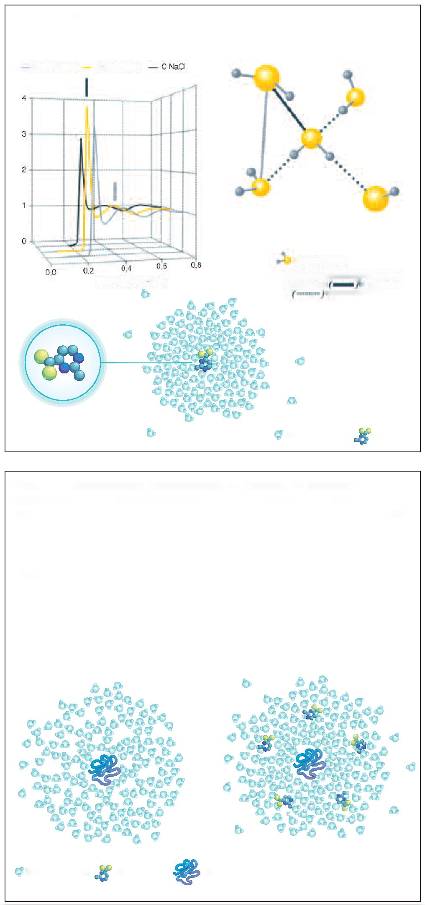

Pure water

With ectoine

Water molecule

**Fig. 1. effect of ectoine on the structure of water [58].**

O-O/nm distance

Tetrahedral water structure with short and long O-O segments

Water molecule

Ectoine

**Fig. 2. stabilization of biomolecules by ectoine according to the selective exclusion model:** *a* - protein in water (the number of water molecules on the protein surface is small); *b* - protein in an aqueous solution of ectoine (the number of water molecules is increased due to the water complex of ectoine); protein stabilization is provided by increased hydrophobic interaction [58].

a

b

Water molecule

Ectoine

Protein

On this basis, in the cosmetic industry ectoines began to be added to topical cosmetic preparations as moisturizing agents for dry, irritated or aged skin [48].

The peculiarity of ectoine action as a therapeutic agent consists in its primary activity. This type of activity is able to stabilize protein molecules and cell membranes on the basis of a kosmotropic effect, which provides an increase in the physical water structure. Ectoine is a potent kosmotrope. Studies of the radial distribution of oxygen in pure water, sodium chloride solution, ectoine solution confirmed the stabilizing effect of ectoine on the water structure (Fig. 1).

Sodium chloride reduces the interaction between water molecules, destroys the water structure and is as a result a chaotrope. In an ectoine-containing solution, the quantity of neighbouring water molecules, on the contrary, increases. Therefore, ectoine improves the interaction of water molecules with each other. It stabilizes the tetrahedral water structure.

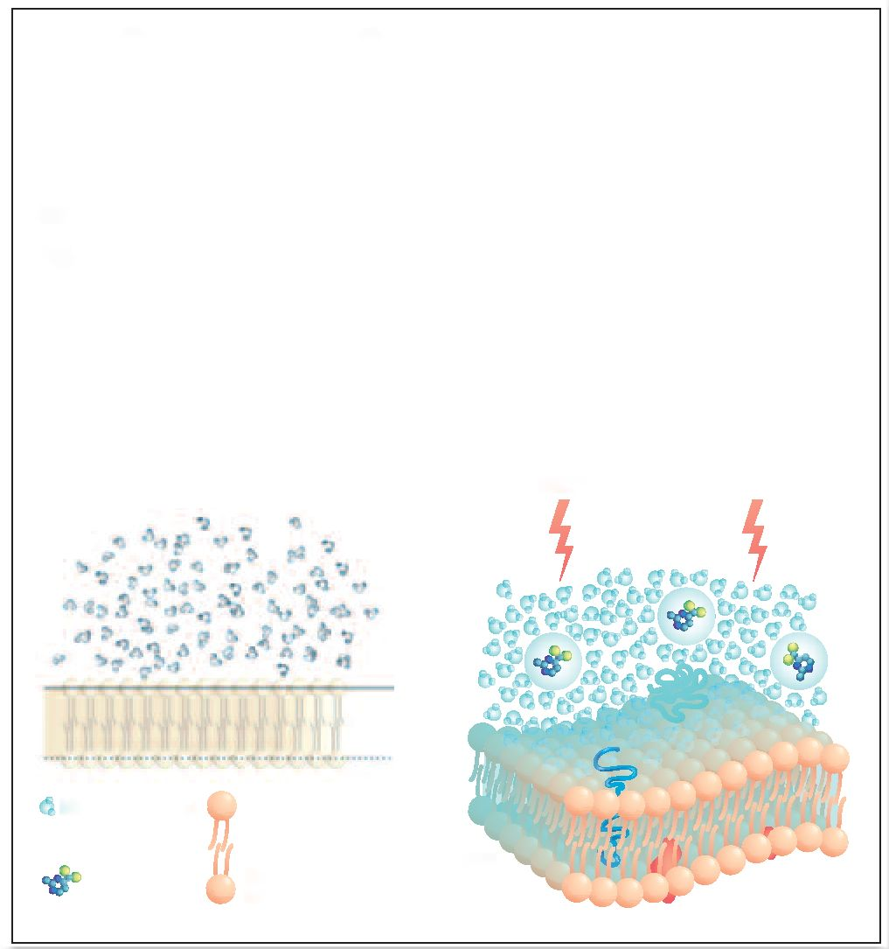

**Fig. 3. stabilization of the membrane and increase of the mobility ofthe membrane under the action of ectoine:** *a* - bilipid membrane in water (bilipid membranes are stabilized due to hydrophilic interaction of the head groups); *b* - bilipid membranes in an aqueous solution of ectoine (the aqueous complex of ectoine enhances the interaction of the head groups with water, as a result of which the mobility of the membranes increases) [58].

a Without ectoine

b With ectoine

Water molecule

Ectoine

Bilipid membrane

Increased mobility within a cell

These results also explain ability of ectoine to stabilize proteins. Maintaining the natural form of a protein is supported by entropy, which leads to the exclusion of the contact of hydrophobic molecules with water. Stabilization of the water structure leads to an increase in the hydrophobic interaction and, accordingly, an increase in the stability of the structure of a protein as a whole.

As a result of the exclusion of ectoine from the hydrate coat of biopolymers, a protective stabilizing coat is formed around such biomolecules - the ectoine water complex (Fig. 2).

The formation of the ectoine water complex and the resulting kosmotropic effect of ectoine on the water structure, described above, can also contribute to the stabilization of mono-bilipid membranes, which can be considered as a model of cell membranes (Fig. 3).

Ectoine is an efficient and long-lasting moisturizing agent that prevents dehydration of the epidermis and is superior to a well-known membrane stabilizer phosphatidylcholine. It also suppresses skin inflammatory processes. This enables us to recommend its preparations for the treatment of atopic dermatitis of moderate severity [50]. In addition, ectoine actively absorbs ultraviolet radiation and protects against the destruction of the DNA of various cells [51, 52]. It is known that the first devices with ectoine were used in 2000, in the form of local cosmetic products in order to moisturize problem areas of the skin [48]. The definition of the term "moisturizer" in professional literature has several semantic revisions. For example, “a product that actively increases skin water content” [53] or “moisturizers are topical agents whose primary task is to prevent and treat dry skin” [54].

To assess the ability of creams based on ectoine to improve the barrier function of the skin, the influence of several products based on ectoine on TEWL was studied (data from Merck KGaA, Darmstadt, Internal report: Ectoin: Added Protection and Care for the Skin). In total,

5 independent studies of products based on ectoine in various concentrations (1–5%) were conducted, in total, 70 patients participated in the studies. The use of ectoine-based products has significantly reduced TEWL in people with sensitive and atopic skin.

The skin of the forearm was irritated by sodium dodecyl sulphate (SDS) in twenty volunteers. TEWL was measured using Tewameter. After the first measurement (t0), the test products were applied to one site 2 times a day for 7 days in accordance with randomization, one site was not treated with the products and it used as a control one. Fig. 4 shows the change of TEWL relative to the baseline (t0); *p* <0.05 when compared with the untreated area; *p*<0.05 when compared with placebo.

A number of further studies focused on the long-term moisturizing effect of ectoine. Ectoine 0.5% and 1% were applied to the forearms of volunteers 2 times a day for 12 days. The degree of skin hydration was evaluated from 8 to 12 days of the study. On the 12th day of the study, the use of the preparation was discontinued and the skin hydration was evaluated 7 days later, on the 19th day of the study. After 8 days of ectoine use, hydration was better than after the use of placebo (improvement up to 200%), and it remained unchanged until the end of the study. Although ectoine was discontinued on the 12th day of the study, the actual level of hydration was maintained for 7 consecutive days, confirming its ability to maintain skin hydration for a long period.

The use of ectoine as a part of medical devices for arresting inflammatory reactions during allergies and atopic dermatitis has a certain positive practice. Current knowledge of AD includes information about pathological changes in immune, microbial, integral skin barriers. In this case, skin barrier disruption can be of physical and chemical nature, which are closely interrelated [56].

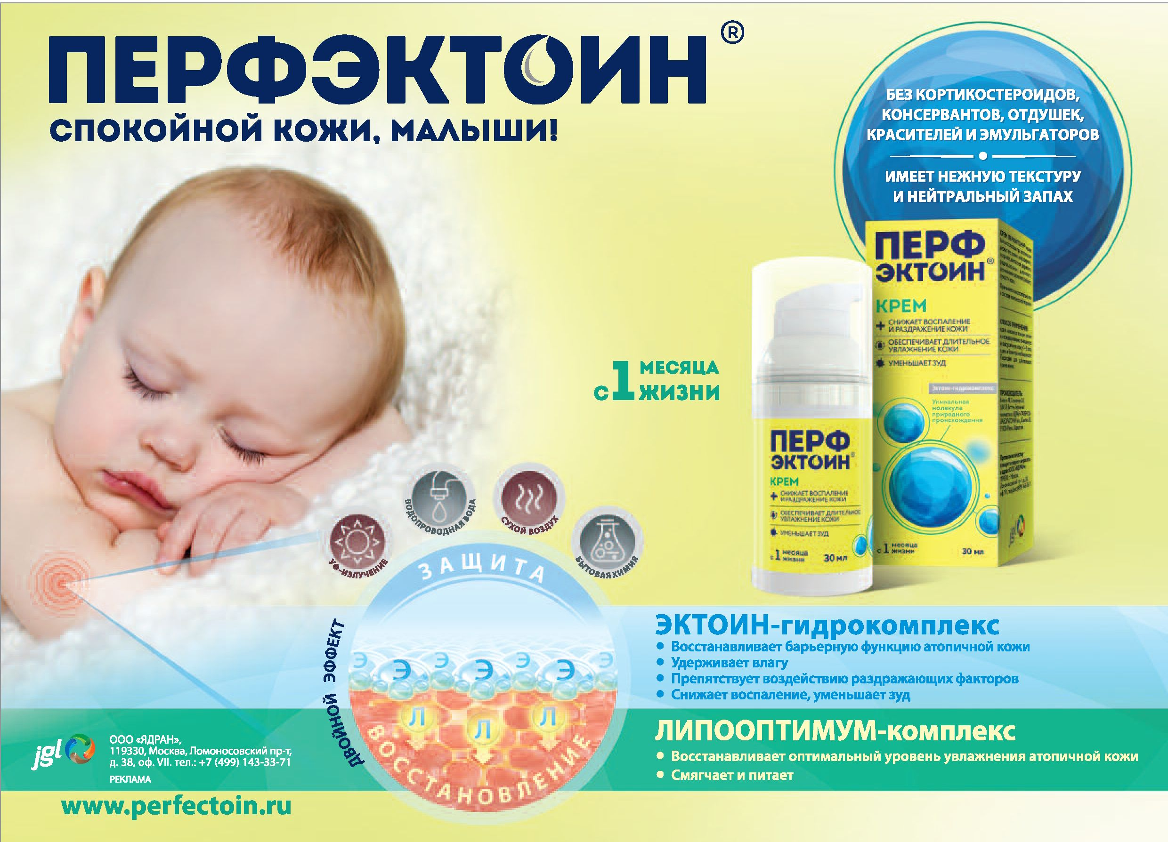

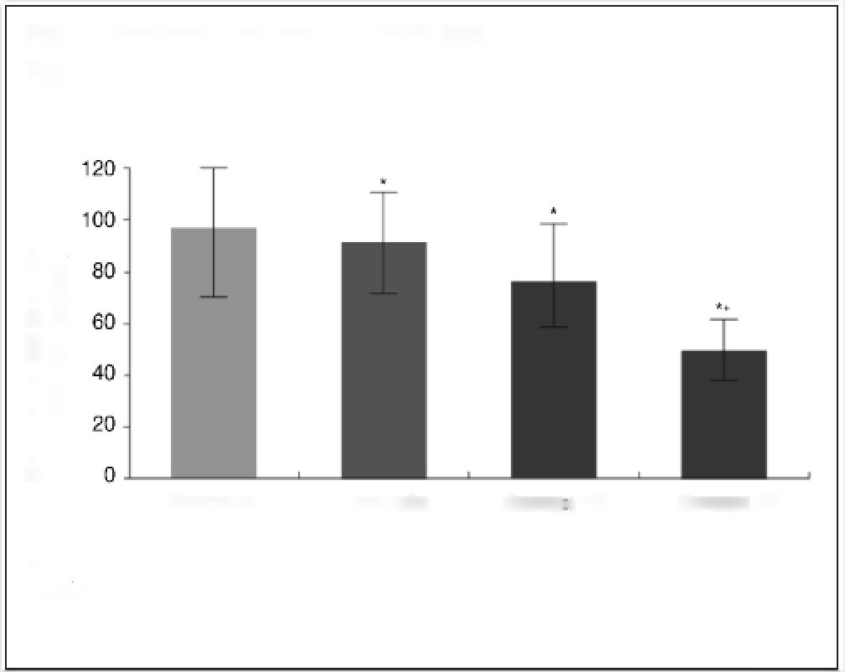

**Fig. 4. effect of ectoine on transepidermal water loss [58].**

Change in TEWL relative to baseline, %

Control

Placebo

Ectoine1%

Ectoine 4%

In 7 days

\**p* <0.05 when compared with the untreated area;

+*p*<0.05 when compared with placebo.

**The safety of ectoine-containing creams.** Ectoine efficacy is combined with a high safety profile for patients, including children. Individual undesirable manifestations during the administration of these prepartaions are carefully analyzed. In general, the administration of a family of commercial creams with ectoine indicates a safe method of treating inflammatory dermatoses in children diagnosed with atopic dermatitis. The absence of harmful impurities (preservatives, dyes, fragrances) in the composition of an active ingredient and excipients ensures the safe use of ectoine cream in infants and children (IUF data, 2014).

**Cream Perfectoin®.** At present, Perfectoin® cream has appeared on the Russian market, the main component of which is a molecule of ectoine at he concentration of 7%. It is combined with any preparations and can be used in complex therapy of atopic dermatitis, eczema, neurodermatitis, psoriasis, contact dermatitis, radiation dermatitis, retinoid dermatitis, cheilitis, dry skin. Due to the ability of ectoine to stabilize and protect the skin barrier, Perfectoin® cream can be used for the proactive treatment of atopic dermatitis. Additionally, Perfectoin® cream contains a complex of vitamins, which restores the optimal level of moisture naturally restoring water-lipid balance. The components of the complex are ceramides, squalane, natural oil lipids (olive and shea butter), *Cardiospermum Halicacabum*, triglycerides of capric and caprylic acids. Due to these components, the cream has a delicate texture, even a small amount is enough to apply over a large area of the skin surface.

# conclusion

During the long period of study and application of ectoine, its biological safety and the necessary biocompatibility for humans have been confirmed. At present, the nomenclature of commercial products containing ectoine has expanded significantly. The clinical use of these agents includes pulmonary, sublingual and oral administration, as well as topical administration. Experiments have not revealed the negative effect of ectoine on the metabolic process of the biological system of a functioning cell. The protective effect caused by the moisturizing and stabilizing effect of ectoine provided the production of a number of promising products for direct application to targeted areas of the skin, the mucous membranes of the respiratory tract and the gastrointestinal tract. The nomenclature included preparations and devices in the form of a nasal spray, oro-dispersible tablets (lozenges), eye drops, solutions for inhalation, for internal and external administration. The protective effect of ectoine on epithelial cells of the skin and mucous membranes of a person is expressed in the physical shadowing of the harmful effects of various external stress factors, such as ultraviolet radiation, unwanted water loss, and pollutants. The metabolite maintains the state of hydration of biological molecules and membranes of tissue cells, which remain almost unchanged during stressful situations. The initial interaction of ectoine with the cellular structures of the epithelium and the kosmotropic effect prevent the possible occurrence (or development) of inflammation under the influence of various harmful factors. At the same time, other natural anti-inflammatory mechanisms are not deteriorated in a human body. Ectoine arrests inflammation exclusively within the framework of the physical protective effect. All this speaks for the apparent priority of the use of ectoine-containing products for the complex treatment of AR and atopic dermatitis, where there is a violation of the epidermal barrier and an hyperimmune reaction [59].

**Conflict of interests.** The author declare that there is not conflict of interests.

**References**

1. Microbiology Today May 16, 2016. https://[www.microbiologysociety.org/uploads/](http://www.microbiologysociety.org/uploads/) assets/uploaded/d141da1f-b538-49f2-b4ca0b04ac5c0b73.pdf
2. Нетрусов А.И., Котова А.Б. Общая микробиология: учеб. М.: Академия, 2007. [Netrusov A.I., Kotova A.B. Obshchaia mikrobiologiia: ucheb. Moscow: Akademiia, 2007 (in Russian).]
3. Durvasala R, Subba Rao DV. Extremophiles: nature`s amazing adapters. In: Extremophiles: from biology to biotechnology. Ed. by R Durvasala, DV Subba Rao. Boca Raton: CRC Press, 2018; p. 1–17.
4. Encyclopedia of Microbiology. Ed. by M Schaechter. Vol 1. Third edition. Academic Press, 2009.
5. Galinski EA, Pfeiffer HP, Truper HG. 1,4,5,6-Tetrahydro-2-methyl-4-pyrimidinecarboxylic acid. A novel cyclic amino acid from halophilic phototrophic bacteria of the genus Ectothiorhodospira. Eur J Biochem 1985; 149 (1): 135–9.
6. Oren A. Life at high salt concentrations. In: Procaryotes. A handbook on biology of bacteria. Ed. by M Dworkin, S Falkow et al. Third edition. Springer Science + Business Media, LLC, 2006; p. 263–82.
7. Jrwin JA. Medical utility of extremophiles. In: Extremophiles: from biology to biotechnology. Ed. by Durvasala R, DV Subba Rao. Boca Raton: CRC Press, 2018; p. 315–40.
8. Oren А. Industrial and environmental applications of halophilic microorganisms.

Environ Technol 2010; 31: 8-9, 825–34. DOI: 10.1080/09593330903370026

1. Bownik A, Stępniewska Z. Ectoine as a promising protective agent in humans and animals. Arh Hig Rada Toksikol 2016; 67: 260–5. Mini-review DOI: 10.1515/aiht- 2016-67-2837
2. Galinski EA. Osmoadaptation in bacteria. Adv Microb Physiol 1995; 37: 273–328.
3. Arakawa T, Timasheff SN. The stabilization of proteins by osmolytes. Biophys J 1985; 47 (3): 411–4.
4. Решетников А.С., Хмеленина В.Н., Троценко Ю.А. Идентификация генов синтеза эктоина у умеренно галофильной альфапротеобактерии Methylarcula marina. Микробиология. 2010; 79 (6): 859–60.

[Reshetnikov A.S., Khmelenina V.N., Trotsenko Iu.A. Identifikatsiia genov sinteza ektoina u umerenno galofil'noi al'faproteobakterii Methylarcula marina. Mikrobiologiia. 2010; 79 (6): 859–60 (in Russian).]

1. Качаев З.М. Идентификация генов биосинтеза эктоина у метилотрофной бактерии Methylarcula marina. Магистерская дис. Пущино, 2010. https://works.doklad.ru/view/S-k7aT8_2KQ/all.html=9.04.19

[Kachaev Z.M. Identifikatsiia genov biosinteza ektoina u metilotrofnoi bakterii Methylarcula marina. Magisterskaia dis. Pushchino, 2010 https://works.doklad.ru/ view/S-k7aT8_2KQ/all.html=9.04.19 (in Russian).]

1. Bergey`s Manual of Systematic Bacteriology. Second Edition, vol. 2. The Proteobacteria Part B. The Gammaproteobacteria. Ed. by DJ Brenner, NR Krieg, JT Staley. Springer, 2005.
2. Намеdi J, Mohammadipanah F, Ventosa A. Systematic and biotechnological aspects of halophilic and halotolerant actinomycetes. Extremophiles 2013; 17 (1): 1–13.
3. Pastor JM, Salvador M, Argandona M et al. Ectoines in cell stress protection: Uses and biotechnological production. Biotechnol Adv 2010; 28: 782–801.
4. Шмарева М.Н. Новые аэробные метилотрофные бактерии из соленых биотопов. Дис. … канд. биол. наук. Пущино, 2016. <http://www.dslib.net/micro-bio-> logy/novye-ajerobnye-metilotrofnye-bakterii-iz-solenyh-biotopov.html=9.04.19 [Shmareva M.N. Novye aerobnye metilotrofnye bakterii iz solenykh biotopov. Dis. … kand. biol. nauk. Pushchino, 2016 (in Russian).]
5. Da Costa MS, Santos H, Galinsky EA. An overview of the role and diversity of compatible solutes in Bacteria and Archaea. Adv Biochem Eng Biotecnol 1998; 61:

117–53.

1. Czech L, Hermann L, Stöveken N et al. Role of the Extremolytes Ectoine and Hydroxyectoine as Stress Protectants and Nutrients: Genetics, Phylogenomics, Biochemistry, and Structural Analysis. Genes 2018; 9: 177; DOI: 10.3390/genes9040177
2. Knapp S, Ladenstein R, Galinski EA. Extrinsic protein stabilization by the naturally occurring osmolytes beta-hydroxyectoine and betaine. Extremophiles 1999; 3: 191–8.
3. Kurz M. Compatible solute influence on nucleic acids: Many questions but few answers. Saline Syst 2008; 4: 6.
4. Barth S, Huhn M, Matthey B et al. Compatible-solute-supported periplasmic expression of functional recombinant proteins under stress conditions. Appl Environ Microbiol 2000; 66: 1572–9.
5. Kolp S, Pietsch M, Galinski EA, Gütschow M. Compatible solutes as protectants for zymogens against proteolysis. Biochim Biophys Acta 2006; 1764: 1234–42. DOI: 10.1016/j.bbapap.2006.04.015
6. Bestvater T, Louis P, Galinski EA. Heterologous ectoine production in Escherichia coli: by-passing the metabolic bottle-neck. Saline Systems 2008; 4: 12. DOI: 10.1186/1746-1448-4-12
7. Schubert T, Maskow T, Benndorf D et al. Continuous synthesis and excretion of the compatible solute ectoine by a transgenic, nonhalophilic bacterium. Appl Environ Microbiol 2007; 73: 3343–7.
8. Moghaieb REA, Tanaka N, Saneoka H et al. Characterization of salt tolerance in ectoine-transformed tobacco plants (Nicotiana tabaccum): photosynthesis, osmotic adjustment, and nitrogen partitioning, Plant Cell Environ 2006; 29: 173–82.
9. Sauer T, Galinski EA. Bacterial milking: a novel bioprocess for production of compatible solutes. Biotechnol Bioengin 1998; 57: 306–13.
10. Frings E, Sauer T, Galinski EA. Production of hydroxyectoin: High cell-density cultivation and osmotic down shocks of Marinococcus strain M52. J Biotechnol 1995; 43: 54–61.
11. https://[www.pharmawiki.ch/wiki/index.php?wiki=Ectoin=9.7.18.](http://www.pharmawiki.ch/wiki/index.php?wiki=Ectoin%3D9.7.18)
12. Roychoudhry A, Bieker A, Häussinger D, Oesterhelt F. Membrane protein stability depends on the concentration of compatible solutes – a single molecule force spectroscopic study. Biol Chem 2013; 394: 1465–74. DOI: 10.1515/hsz-2013-0173
13. Lippert K, Galinski EA. Enzyme stabilization be ectoine-type compatible solutes: protection against heating, freezing and drying. Appl Microbiol Biotechnol 1992; 37:61-5. DOI: 10.1007/BF00174204
14. Zhang L, Wang Y, Zhang C et al. Supplementation effect of ectoine on thermostability of phytase. J Biosci Bioeng 2006; 102: 560–3. DOI: 10.1263/jbb.102.560
15. Lapidot A, Ben-Asher E, Eisenstein M. Tetrahydropyrimidine derivatives inhibit binding of a Tat-like, arginine-containing peptide, to HIV TAR RNA in vitro. FEBS Lett 1995; 367: 33–8. DOI: 10.1016/0014-5793(95)00514-A
16. Tanne C, Golovina EA, Hoekstra FA et al. Glass-forming property of hydroxyectoine is the cause of its superior function as a desiccation protectant. Front Microbiol

2014; 5: 150. DOI: 0.3389/fmicb.2014.00150

1. Cruz PE, Silva AC, Roldão A et al. Screening of novel excipients for improving the stability of retroviral and adenoviral vectors. Biotechnol Prog 2006; 22: 568–76. DOI: 10.1021/bp050294y
2. Unfried K, Kroker M, Autengruber A et al. The compatible solute ectoine reduces the exacerbating effect of environmental model particles on the immune response of the airways. J Allergy Volume 2014; Article ID 708458. <http://dx.doi.org/> 10.1155/2014/708458
3. https://clinicaltrials.gov/ct2/show/NCT01471184=1.09.18
4. Eichel A, Bilstein A, Werkhauser N, Mosges R. Meta-Analysis of the Efficacy of Ectoine Nasal Spray in Patients with Allergic Rhinoconjunctivitis. J Allergy 2014; Article ID 292545. <http://dx.doi.org/10.1155/2014/292545>
5. Werkhauser N, Bilstein A, Sonnemann U. Treatment of allergic rhinitis with ectoine containing nasal spray in comparison with azelastatine containing nasal spray and eye drops or with cromoglycic acid contaiting nasal spray. J Allergy 2014; Article ID 176597. <http://dx.doi.org/10.1155/2014/176597>
6. Рязанцев С.В. Барьерная терапия – новое направление в лечении аллергического ринита. Рос. оториноларингология. 2014; 2: 148–53.

[Riazantsev S.V. Bar'ernaia terapiia – novoe napravlenie v lechenii allergicheskogo rinita. Ros. otorinolaringologiia. 2014; 2: 148–53 (in Russian).]

1. Минаева Н.В., Ширяева Д.М. Сравнительная оценка эффективности лечения детей с сезонным аллергическим ринитом антигистаминным препаратом в комбинации с назальным спреем на основе эктоина и монотерапии антигистаминным препаратом: результаты открытого рандомизированного исследования. Вопр. современ. педиатрии. 2015; 14 (4): 483–8. https://doi.org/10.15690/vsp.v14.i4.1387 [Minaeva N.V., Shiriaeva D.M. Sravnitel'naia otsenka effektivnosti lecheniia detei s sezonnym allergicheskim rinitom antigistaminnym preparatom v kombinatsii s nazal'nym spreem na osnove ektoina i monoterapii antigistaminnym preparatom: rezul'taty otkrytogo randomizirovannogo issledovaniia. Vopr. sovremen. pediatrii. 2015; 14 (4): 483–8 (in Russian).]
2. Кайб И.Д., Петрушина А.Д., Майер Е.Ю. и др. Клиническая эффективность препарата Аква Марис® Сенс у детей и подростков с аллергическим ринитом. Педиатрия. 2016; 95 (6): 101–4.

[Kaib I.D., Petrushina A.D., Maier E.Iu. et al. Klinicheskaia effektivnost' preparata Akva MarisR Sens u detei i podrostkov s allergicheskim rinitom. Pediatriia. 2016; 95 (6): 101–4 (in Russian).]

1. Барденикова С.И., Зайцева О.В., Снитко С.Ю. и др. Эффективность барьерной терапии назальным спреем Аква Марис® Сенс у детей с круглогодичным аллергическим ринитом. Педиатрия. 2016; 95 (2): 113–23.

[Bardenikova S.I., Zaitseva O.V., Snitko S.Iu. et al. Effektivnost' bar'ernoi terapii nazal'nym spreem Akva MarisR Sens u detei s kruglogodichnym allergicheskim rinitom. Pediatriia. 2016; 95 (2): 113–23 (in Russian).]

1. Камаев А.В., Трусова О.В. Клиническая эффективность эктоина (ANS01) в форме назального спрея (препарат Аква Марис Сенс) в комплексной терапии персистирующего аллергического ринита у детей и подростков. Рос. оториноларингология. 2015; 4: 131–43.

[Kamaev A.V., Trusova O.V. Klinicheskaia effektivnost' ektoina (ANS01) v forme nazal'nogo spreia (preparat Akva Maris Sens) v kompleksnoi terapii persistiruiushchego allergicheskogo rinita u detei i podrostkov. Ros. otorinolaringologiia. 2015; 4: 131–43 (in Russian).]

1. Мокроносова М.А., Желтикова Т.М., Арефьева А., Тарасова Г.Д. Терапевтический эффект препарата Аква Марис Сенс у больных с аллергическим интермиттирующим ринитом. Рос. оториноларингология. 2017; 2: 142–8.

[Mokronosova M.A., Zheltikova T.M., Aref'eva A., Tarasova G.D. Terapevticheskii effekt preparata Akva Maris Sens u bol'nykh s allergicheskim intermittiruiushchim rinitom. Ros. otorinolaringologiia. 2017; 2: 142–8 (in Russian).]

1. [http://www.ectoin.net/index.php/EN/anwendung/=1.9.18](http://www.ectoin.net/index.php/EN/anwendung/%3D1.9.18)
2. Graf R, Anzali S, Buenger J et al. The multifunctional role of ectoine as a natural cell protectant. Clin Dermatol 2008; 26: 326–33. DOI: 10.1016/j.clindermatol.2008.01.002
3. Beyer N, Driller H, Bünger J. Ectoine – a innovative, multi-functional active substance for the cosmetic industry. Seifen Öle Fette Wachse J 2000; 126: 26–9.
4. Chao Yuan. Exploratory research for pathogenesis of papulopustular rosacea and skin barrier research in Besançon and Shanghai. Dermatology. Université Bourgogne Franche-Comté, 2017. https://tel.archives-ouvertes.fr/tel-01767270/document=9.04.19
5. Marini A, Reinelt K, Krutmann J, Bilstein A. Ectoine – containing cream in the treatment of mild to moderate atopic dermatitis: a randomised, comparator-controlled, intra-individual double-blind, multi-center trial. Skin Pharmacol Physiol 2014; 27: 57–65. DOI: 10.1159/000351381
6. Botta C, Di Giorgio C, Sabatier AS, De Meo M. Genotoxicity of visible light (400-800 nm) and photoprotection assessment of ectoin, L-ergothioneine and mannitol and four sunscreens. J Photochem Photobiol 2008; 91: 24–34. DOI: 10.1016/j.jphotobiol.2008.01.008
7. Buenger J, Driller H. Ectoin: An effective natural substance to prevent UVA-induced premature photoaging. Skin Pharmacol Physiol 2004; 17: 232–7. DOI: 10.1159/000080216
8. Idson B. Moisturizers, emollients and bath oils. In: Principles of cosmetics for the dermatologist. Ed. by: P Frost, SN Horwitz. St.Loius, MO: CV Mosby, 1982; p. 37–40.
9. Lynde CW. Moisturizers: What They Are And How They Work. Skin Therapy Letter 2001:6 N 13 December 1. <http://www.skintherapyletter.com/eczema/how-moistu-> rizers-work/=8.10.18
10. Hannon CW, Maibach HI. Efficacy of moisturizers assessed through bioengineering techniques. In: Textbook of cosmetic dermatology. Ed. by R Baran, HI Maibach. 3-ed ed. London: Taylor & Francis, 2005; p. 573–612.
11. Seite S, Bieber Т. Barrier function and microbiotic dysbiosis in atopic dermatitis. Clinical, Cosmetic and Investigational Dermatology 2015; 8: 479–83.
12. Wollina U. Microbiome in atopic dermatitis. Clinical, Cosmetic and Investigational Dermatology 2017; 10: 51–6.
13. Scientific Information: Ectoin the natural stress-protecting molecule. Bitop AG, Germany. <http://www.ectoin.net/data/download/bitop_basisbroschuere.pdf>
14. Wang D, Beck LA. Immunologic targets in atopic dermatitis and emerging therapies: an update. Am J Clin Dermatol 2016; 17: 425–43. <http://dx.doi.org/10.1007/s40257-> 016-0205-5

**Information about the author**

**Vladimir I. Kocherovets** – D. Sci. (Med.), Full Prof., I.M.Sechenov First Moscow State Medical University. Е-mail: [kftif@mail.ru](mailto:kftif@mail.ru)

**the article received:** 22.03.2019

**the article approved for publication:** 08.04.2019